**Subhan Bin Yousaf**

**Section B**

**481281**

**FOP Lab Manual 6**

**Home Tasks**

**Task 1 :**

#include <iostream>

using namespace std;

int main (){

int sum = 0;

for (int i = 2; i <= 50; i++) {

bool Prime = true;

for (int j = 2; j < i; j++) {

if (i % j == 0) {

Prime = false;

break;

}

}

if (Prime) {

sum += i;

}

}

cout << "The sum of prime numbers from 1 to 50 is: " << sum << endl;

return 0;

}



**Task 2 :**

#include <iostream>

using namespace std;

int main (){

for (int i=1; i<=5; i++){

for (int j=1; j<=i; j++){

cout<<j<< '\t' ;

}

cout << endl;

}

return 0;

}

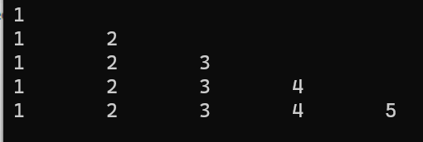

**Task 3 :**

#include <iostream>

using namespace std;

int main (){

int a,b;

int k=0;

cout<<"Enter rows needed"<<endl;

cin>>a;

while (k<=a){

b=1;

while (b<=k){

cout<< k << '\t';

b++;

}

cout<<endl;

k++;

}

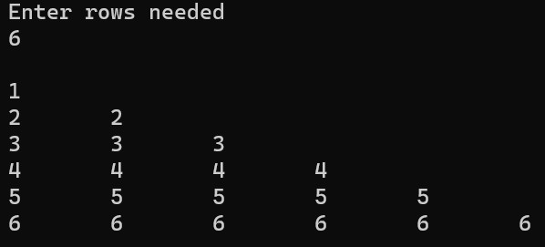 return 0;

}